SEPARATING MIXTURES

1. Undissolved Solids / Suspensions

Decanting

• Pour the liquid (solvent) off first.
• Solid remains behind.
• Not 100 % effective - some liquid stays behind.

e.g. Rocky soil in water.

Sieving

• Sieves have holes in them that will only let certain sized materials
through.

e.g. Draining water from rice or spaghetti when cooking.
Used in mining in a range of processes where only crushed rock
of a certain size can be used.

Filtering
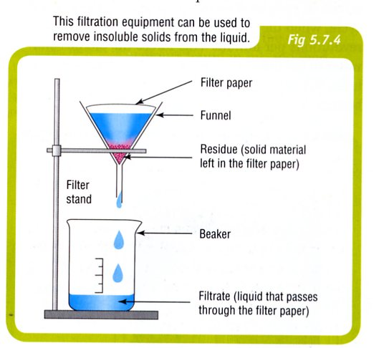
• 100 % effective.
• Solid remains trapped in the filter
paper - called residue.
• Filtered liquid is called the filtrate.

e.g. Sand in water.

• Many different filters - air filters
in air conditioner, petrol filter in
cars, swimming pools, tea bags,
etc.

Centrifuging
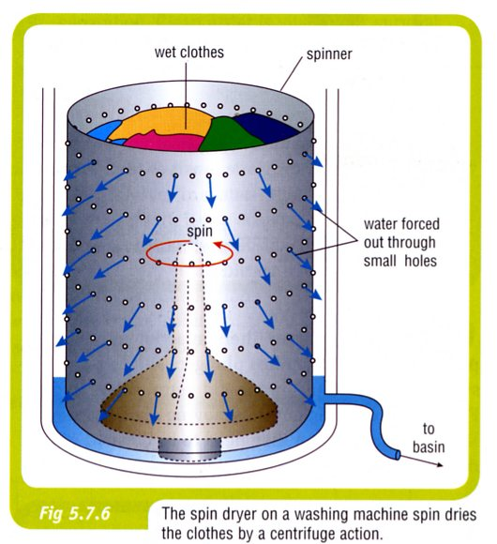
• Spin quickly, forcing the solids and
liquids to move outwards.
• Holes allow the liquid to move through,
leaving the solid behind.

e.g. Spin dryer of a washing machine -
clothes stay inside while water is
forced through the holes.

• Have many applications in medicine and
industry.

e.g. In medicine they can be used to separate blood into its cells and
liquid (plasma).

Electrostatic precipitation

• Used in industry to remove impurities from smoke released from large
chimneys.
• As the smoke moves up the chimney it receives an electric charge, which
attracts the particles to the collecting plates at the side of
the chimney.

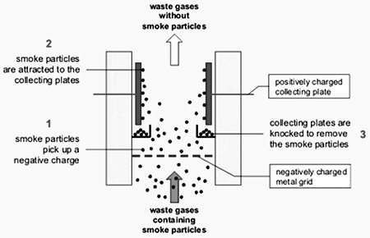

Froth flotation

• Used to remove metals from minerals in mining.
• The metal-containing mineral is finely crushed to release the metal and
mixed with water and special chemicals called ‘frothing agents’.
• When air bubbles are blown through the mixture, the metal particles cling
to the bubbles and come to the surface.

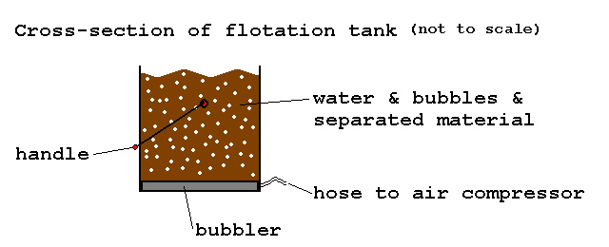

2. Solutions

Evaporation

• Removes solvent but leaves solute behind.
• Only recovers the solute.

e.g. Evaporate seawater to recover salt.
Separate copper sulphate from solution.

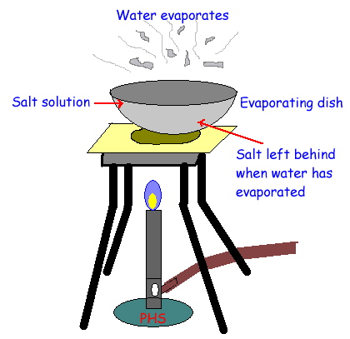

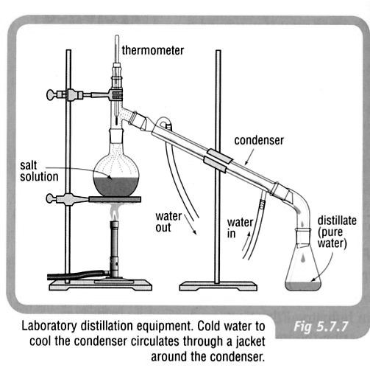
Distillation

• Recovers solute and solvent.
• Use condensation to recover the
solvent.

e.g. Recover salt and water separately
from a solution.

• Oil is distilled to make petrol,
kerosene, diesel and lubricating oils.

Desalination

• Name given to the process of removing salt and other impurities from salt
water.
• There are two main desalination processes:

1. Thermal desalination - same as that described above.

2. Reverse osmosis - involves ‘pushing’ water through a special
membrane, removing the salt.

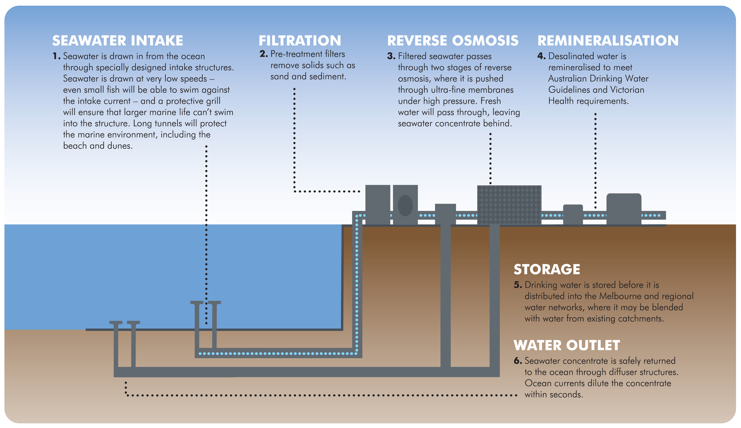

Chromatography

• Separates small quantities of dissolved materials

e.g. Separates coloured inks into pigments by moving through paper.
Used in forensic science to identify blood samples and DNA.

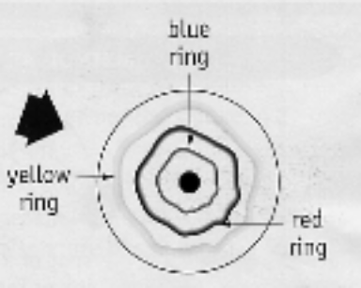

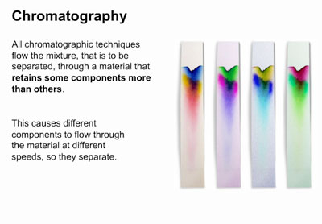

3. Separating Solids

(a) One soluble - one insoluble.

e.g. Copper sulphate in water.

• Add water to dissolve the soluble substance.
• Filter to recover the insoluble substance.
• Evaporate the filtrate to recover the soluble substance.

(b) Magnetic separation.

e.g. Iron filings in sand.

• Works only for magnetic materials (iron/steel, cobalt, nickel).
• No use for metals such as aluminium, gold, silver and copper.

(c) Insoluble substance floats, the other sinks.

e.g. Cork and sand.

• Skim the floating substance off.
• Filter to recover the other substance.

(d) One solid heavier than the other.

e.g. gold in soil

• Gold is heavier than soil and remains in the pan during "panning".

